**FPGA Karaoke**

A Final Project Plan for ECE383

By

C2C Mark A. Demore II

April 12, 2018

1. **Level-1 Design**:

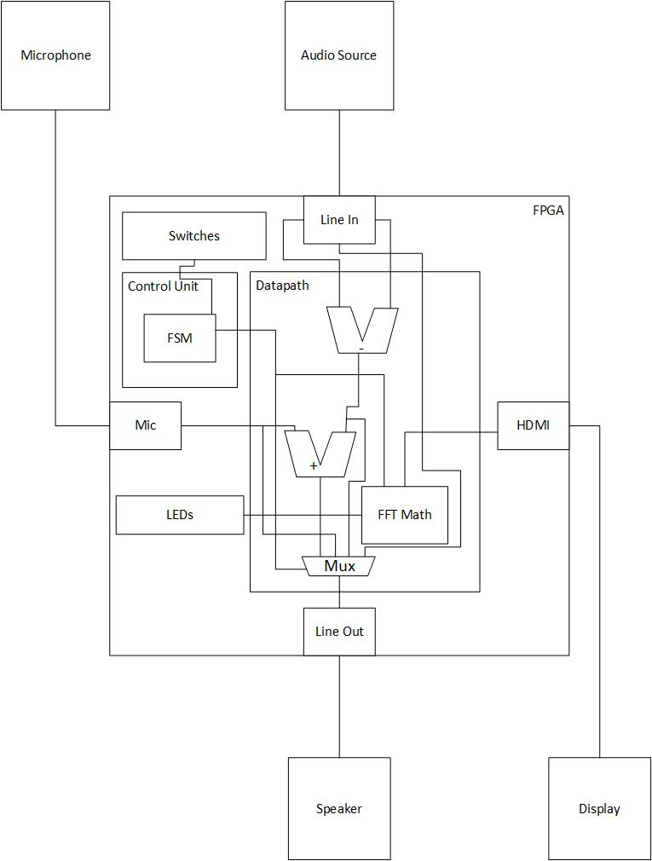

Control Unit FSM:

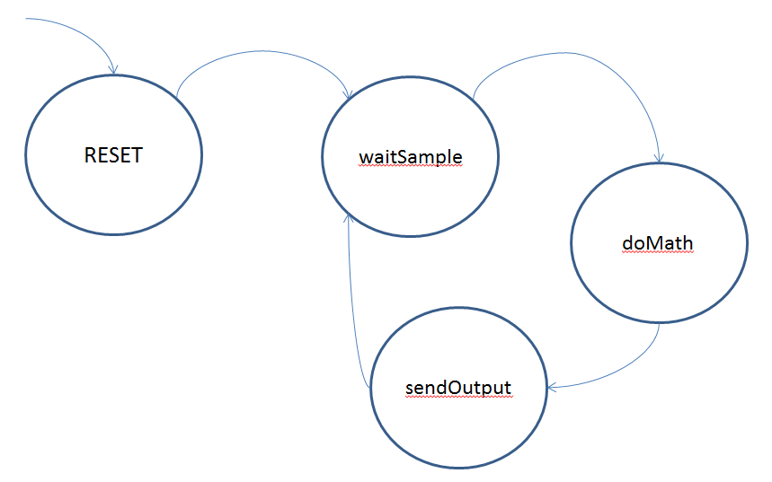

1. **Calculations:**

I need something here for the FFT stuff that I have not discussed with Dr. York yet.

1. **Bill of Materials:**

* Nexys Video FPGA
* Microphone
* Speaker
* Monitor
* Audio Source (phone)

1. **Milestone I:**

Implement voice-stripping. Use a subtractor between the right and left channels to remove the vocals from audio input and output it via the speaker. This will have to be verified by ear.

1. **Milestone II:**

Implement switches and microphone input. Switches will determine which audio to output: with or without voice-stripping and with or without microphone input. A test-bench can be used to verify this functionality, as well as complete implementation on the board, verified through the speaker by ear.

1. **Functionality:**

**Basic –** Complete Milestones I and II

**B –** Implement FFT calculations and basic display on LEDs

**A –** Implement an FFT plot capable of displaying the full range of input on the display via HDMI

FFT will be extensively tested in a test-bench. All will be verified by performance on the FPGA and documented via video.